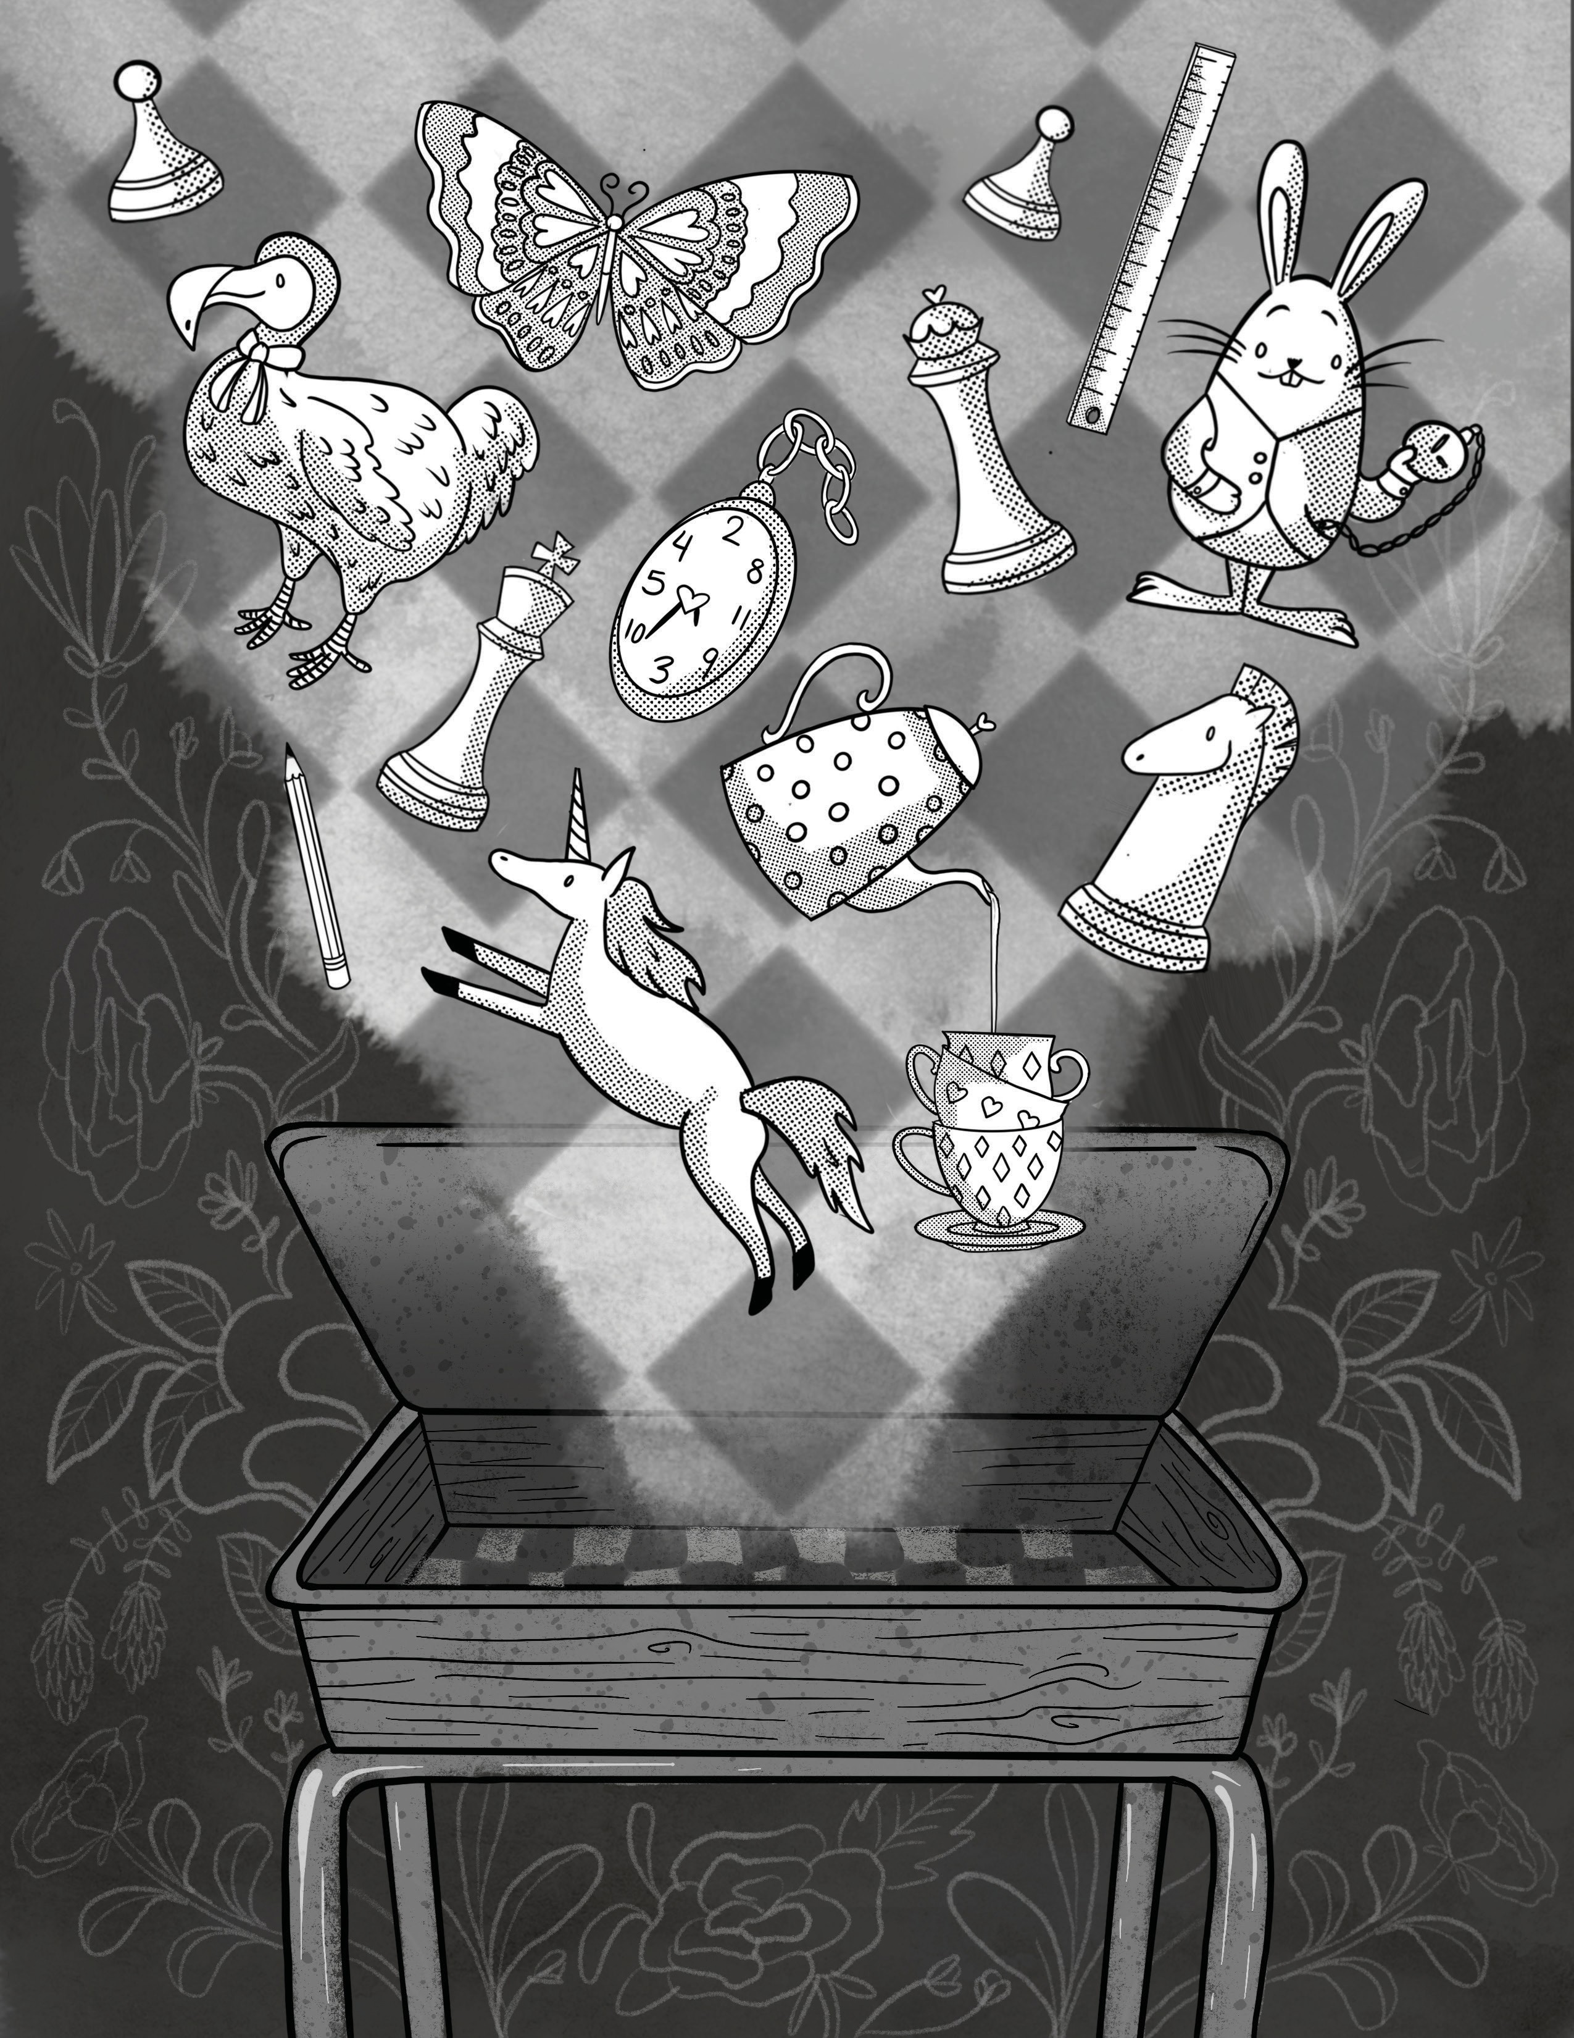

BAD HATS’

ALICE IN
WONDERLAND
spring 2021
prODUCTiOn spOnsOr

BAD HATS’ ALICE IN WONDERLAND

How often do we let ourselves wonder? As children, we’re the experts at it.
We wrestle openly with the oddities of the world, rolling the pieces of the things we know over in our minds, but we’re very soon told that everything has an answer, and a place, even us. So, where does all that wondering go?
What happens when we stop being allowed to not know? I wanted to write
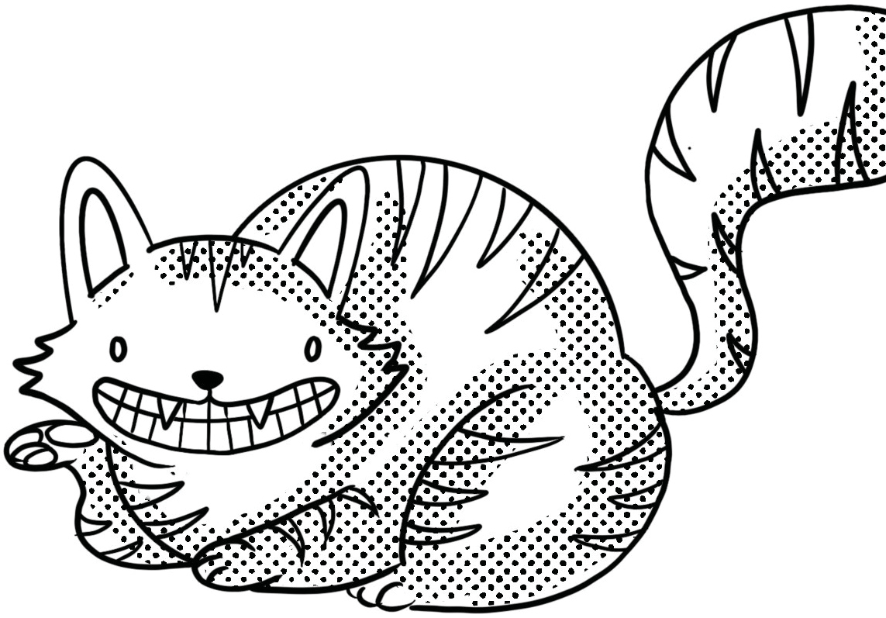
a piece about leaning into the unknown, embracing the change that lives there, and believing that our greatest power lies in our curiosity.
On behalf of everyone at Soulpepper and Bad Hats, we hope you enjoy this show with those you love.
Fiona Sauder, Artistic Director, Bad Hats

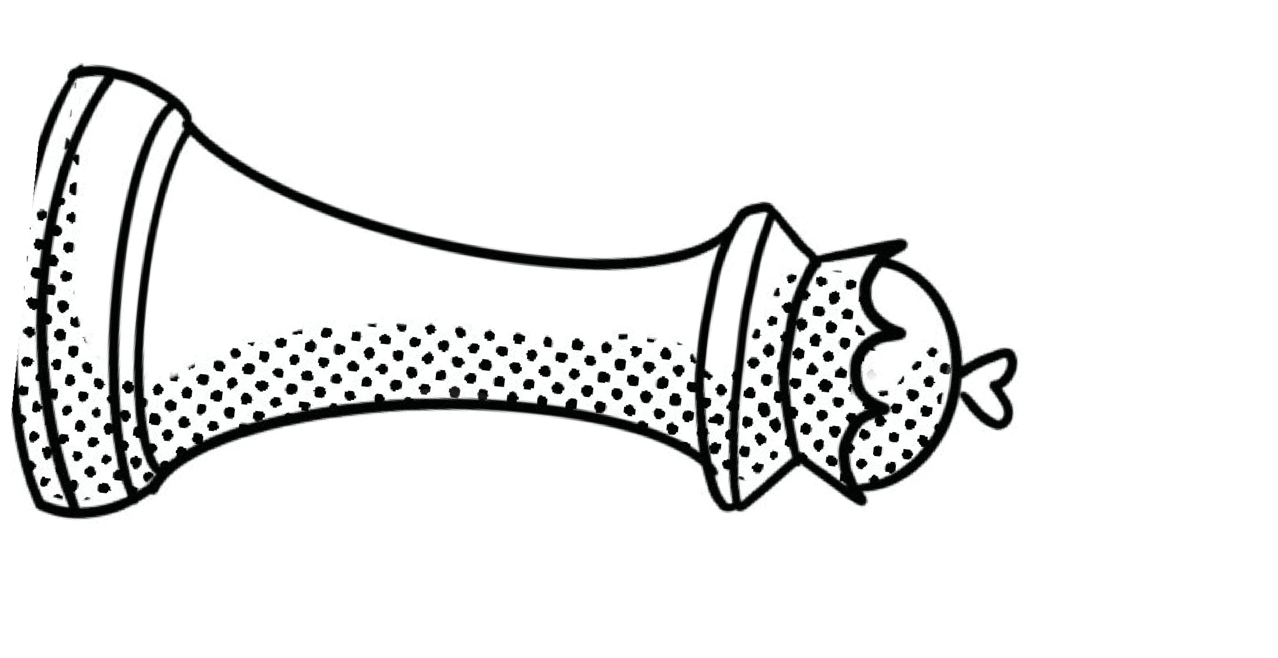
Cast

Tess Benger
Alice
Landon Doak
Todd, Tweedle Dum, Hatter
Phoebe Hu
Rose, Duck, Unicorn

Creative Team

Sue Miner
Director
Reza Jacobs
Music Director
Cameron Carver
Choreographer
Logan Raju Cracknell
Lighting Designer
Fiona Sauder
Adaptor
Richard Lam
Douggie, Dodo, Lily
Jacob Macinnis
Maddie, Owl, Buttercup, Bill, Caterpillar
Matt Pilipiak
Mr. Charles, Rabbit

Landon Doak
Co-Composer
Matt Pilipiak
Dramaturg, Associate Producer
Victor Pokinko
Co-Composer, Line Producer, Executive Producer
Lauren Vandervoort
Associate Producer
Ming Wong
Costume Designer
Fiona Sauder
Tod, Tweedle Dee, Hare
Vanessa Sears
Ruby, Red Queen
Jonathan Tan
Cheshire Cat

Joyce Padua
Assistant Costume Designer
Lisa Humber
1st AD, Stage Manager
Victoria Wang
2nd AD, Assistant Stage Manager
Cameron Carver
Broadcast Rehearsal AD
Phoebe Hu
Dance Captain

We hope you enjoy the event! Please share your artwork and creativity with us on social media using #spAlice

Katie Burns, Activity Book Illustrations

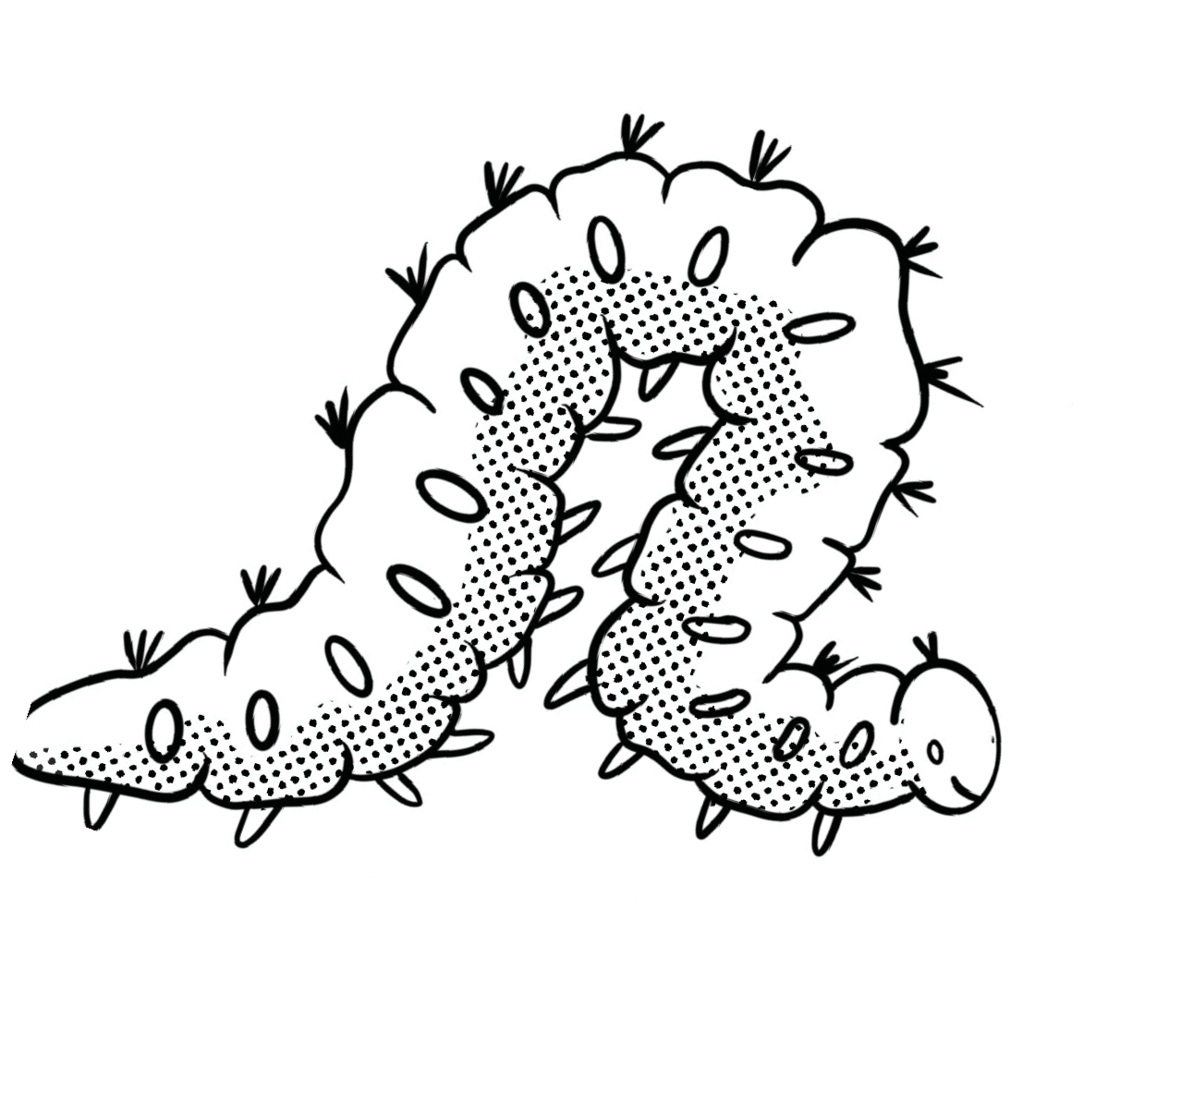
WATCH FOR CLUES

As you enjoy the performance, pay attention for answers to the below questions and solve the final riddle.

- What does Alice see running across the school yard?

(2 words, 5 letters and 6 letters)
- Noon is also called Twelve

(6 letter word)
- If it’s not sense, it must be

(8 letter word)
- The bottle has a label on it that says

(2 words, 5 letters and 2 letters)
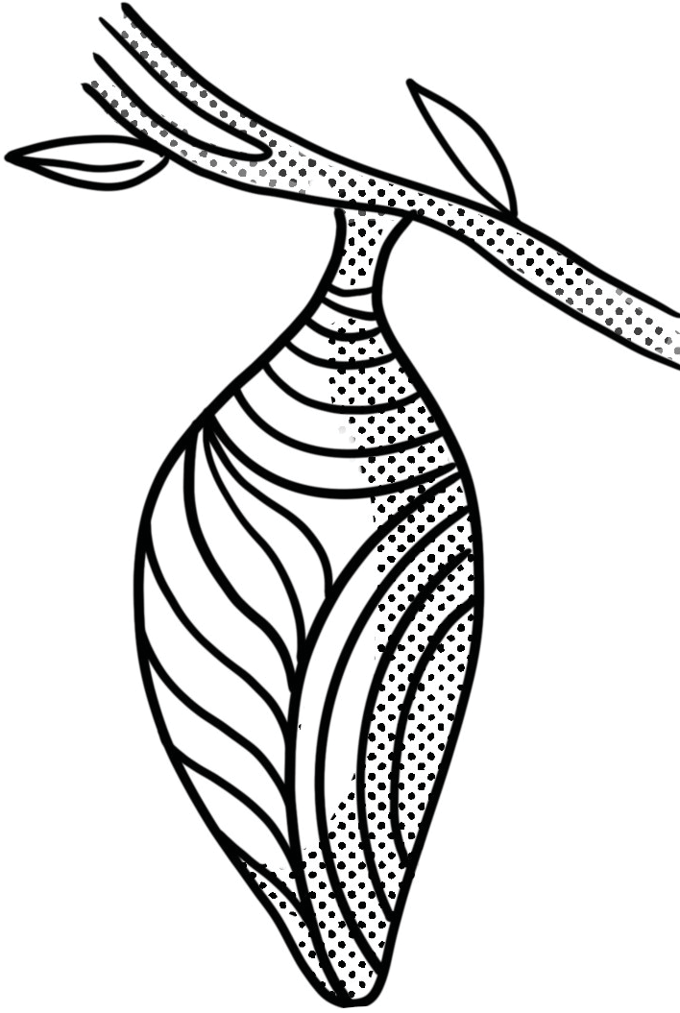
- Alice wants to get to the Square on the chess board

(6 letter word)
- If it isn’t left, it must be

(5 letter word)
- Bill is a

(6 letter word)
- The rabbit thinks Alice is his maid, Mary

(3 letter word)
- When Alice goes into the forest, she forgets her

(4 letter word)
10. Alice got to Wonderland by falling a rabbit hole

(4 letter word)
BONUS: What do the first letters of all the answers spell?
(10 letter word)
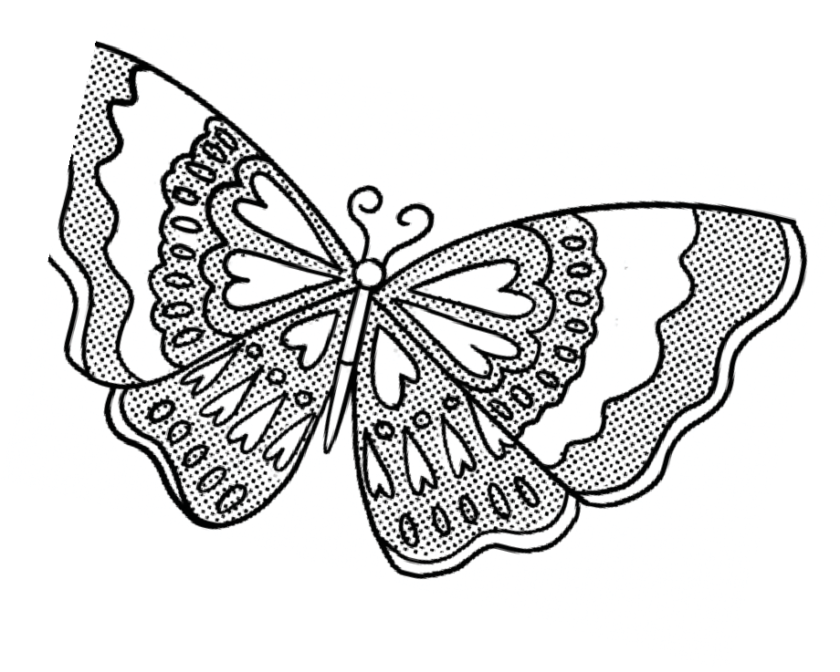

SEARCHING FOR ALICE

O | P | F | K | C | L | O | R | J | X | N | K | P | H | R
W | B | A | U | L | K | E | A | L | O | T | A | I | E | B
F | H | O | S | O | E | U | V | N | M | M | C | T | P | U
C | O | I | O | C | P | D | S | O | V | P | S | Q | Y | T
Q | H | O | T | K | K | E | A | D | H | N | R | W | G | T
O | K | E | S | E | N | V | R | P | O | S | E | S | G | E
C | H | E | S | S | R | C | C | M | T | V | W | Q | G | R
N | M | N | E | H | S | A | U | N | I | C | O | R | N | C
A | M | U | R | N | I | T | B | E | C | I | L | A | O | U
M | H | E | E | N | D | R | A | B | E | V | F | Q | D | P
H | K | E | H | X | T | L | E | H | I | Z | A | F | O | Z
B | U | J | I | E | B | B | U | Q | D | T | P | T | D | B
Q | E | L | D | E | E | W | T | E | E | A | O | N | G | Z
D | N | A | L | R | E | D | N | O | W | D | B | T | U | M
Y | U | R | S | O | U | L | P | E | P | P | E | R | P | W

Words to find: (Words can go in any direction. Words do not share letters.)

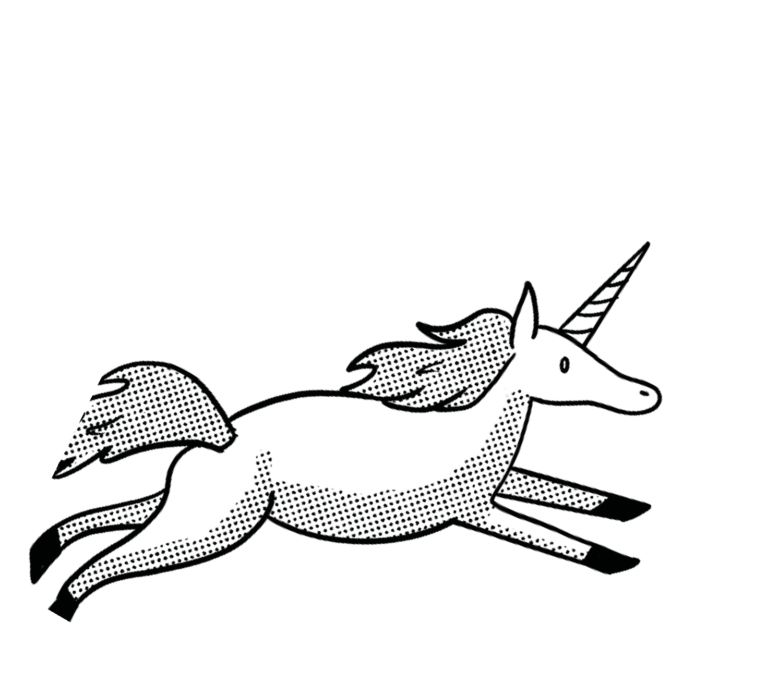Alice Cat Clock Monster Shovel Unicorn
BadHats Cheshire Dodo Nonsense WhiteRabbit Soulpepper
Buttercup Chess Flower Queen Tweedle Wonderland

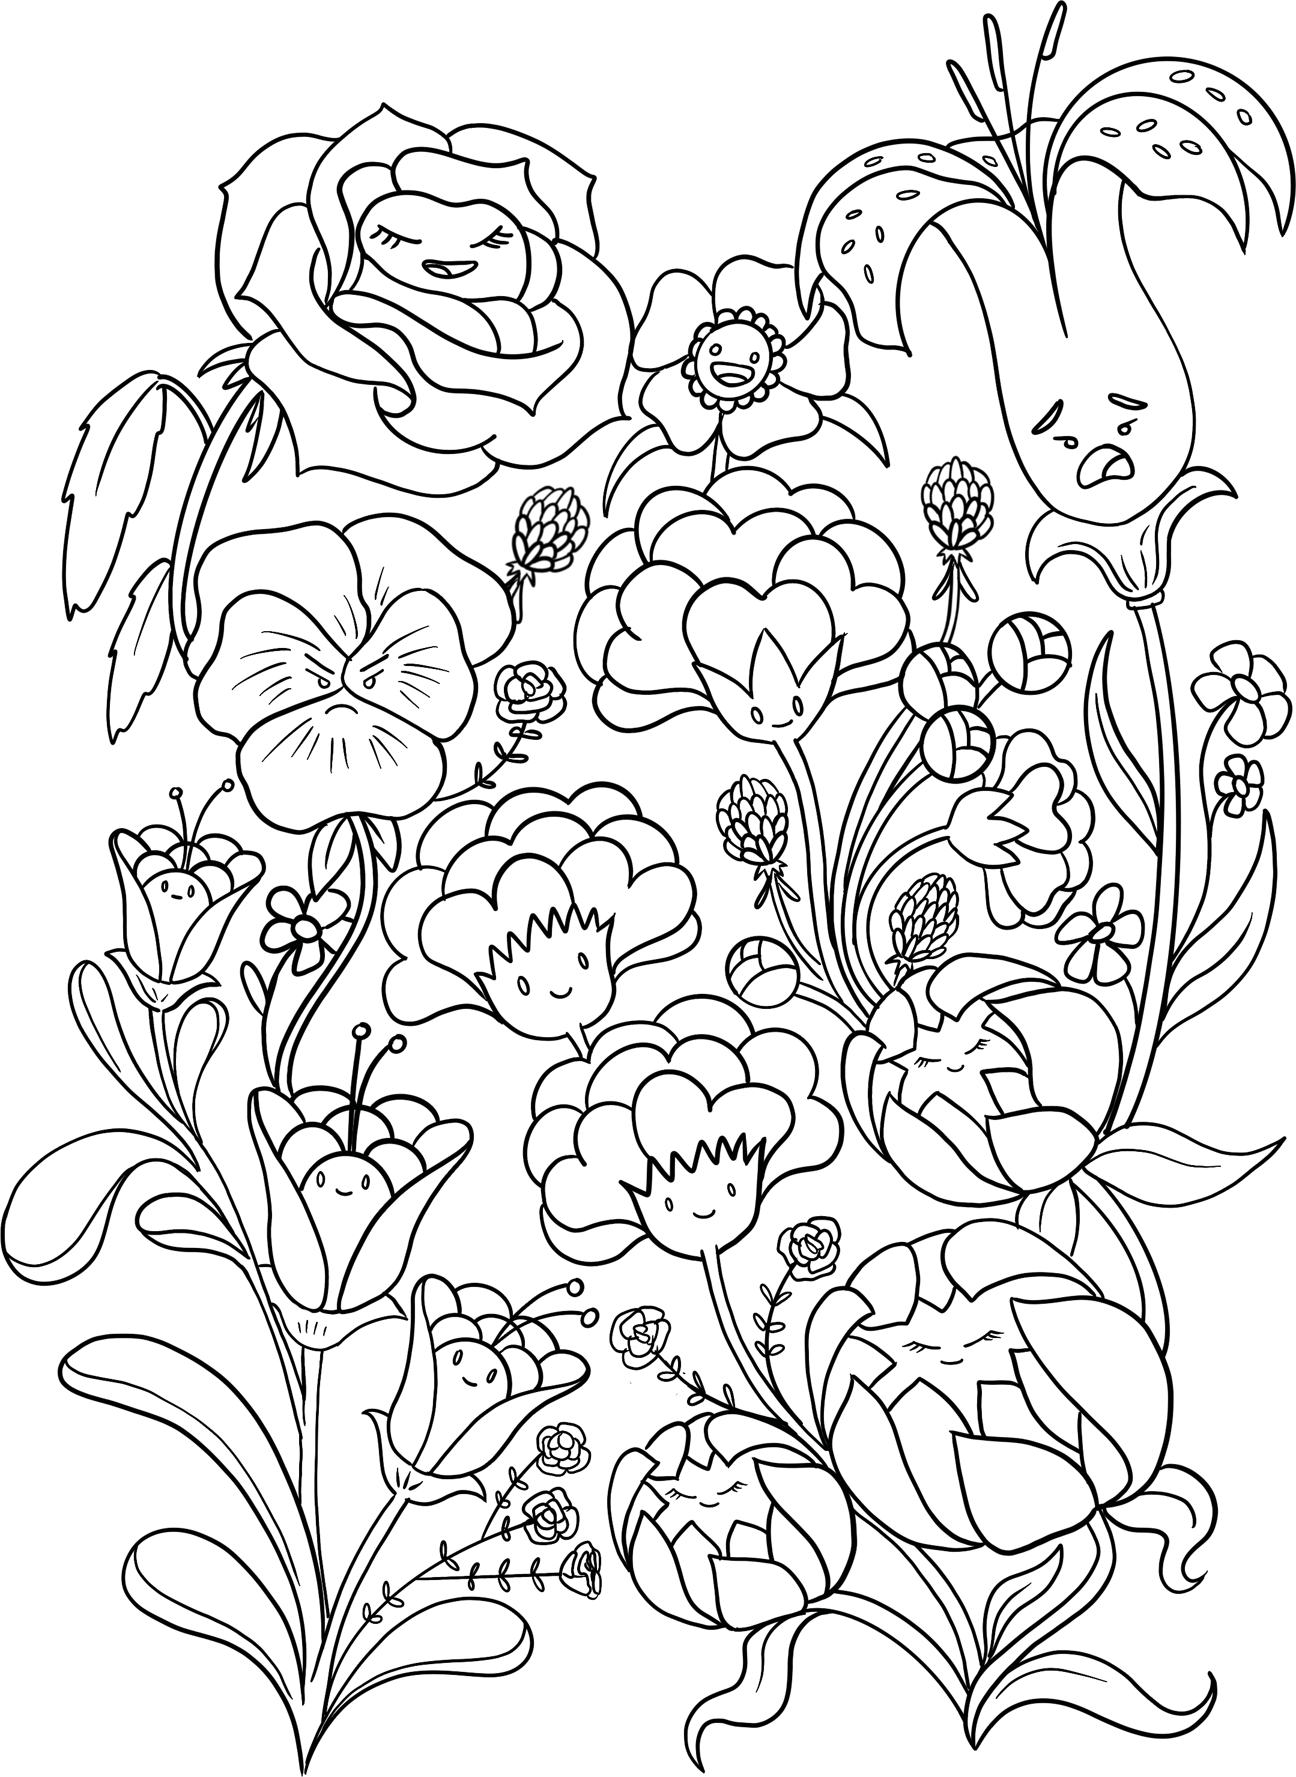
INTO THE WILD GARDEN

Alice finds herself in a garden filled with many curious flowers. What colour do you imagine them?

MAKE YOUR OWN POEM

Alice’s world is filled with poetry. Below is an example, but some words are missing. Can you fill in the blanks to make your own?

Verb: an action word
Adverb: word that describes how you do the action
Noun: a person, place or thing
Adjective: descriptive words

We must have a Game!
The rules of the game are quite , you know
(Adjective)

But I can’t guarantee that you’ll win

You have to be and as you go

(Adjective)

And before you begin
(Verb)
(Adjective)

You start as a , and you’ll move square to square
(Noun)

It’s and and long
(Adjective ending in Y) (Adjective)

Sometimes you’ll feel and , just beware

(Adjective)

That you very well might get it wrong
(Adjective)

Now each Square is , so ready your mind
(Adjective)

The journey is
Remember to

(Adjectiv)

(Verb)
, so they say
the things that you find
And look out for on the way
(Name)

If you get to the end with a on your face
(Noun)
I’ll be ever so impressed
(Adverb)

So stick to the , and keep up the pace
(Noun)
And if you can’t , take a guess
(Verb)

Now winning the game is a task
(Adjective)
And losing’s the of crimes
(Adjective ending is ‘est’)
How do I know all these , you might ask?
(Plural noun)
I’ve done it myself, times
(Number)

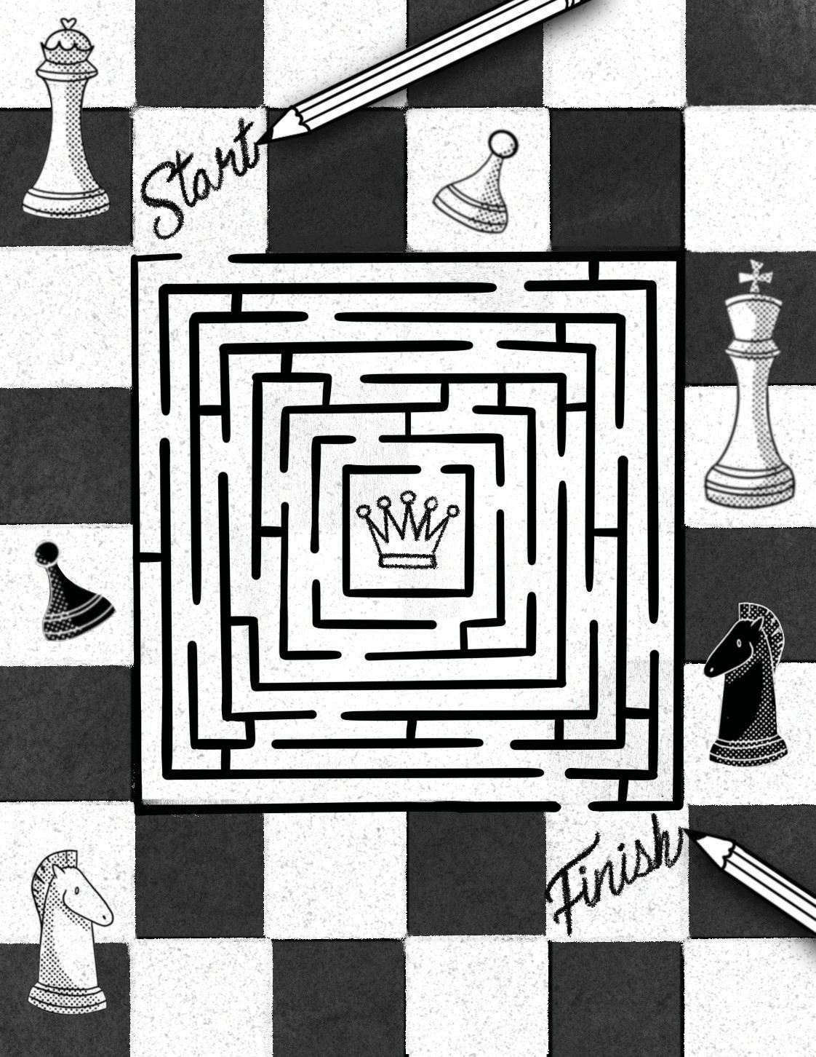

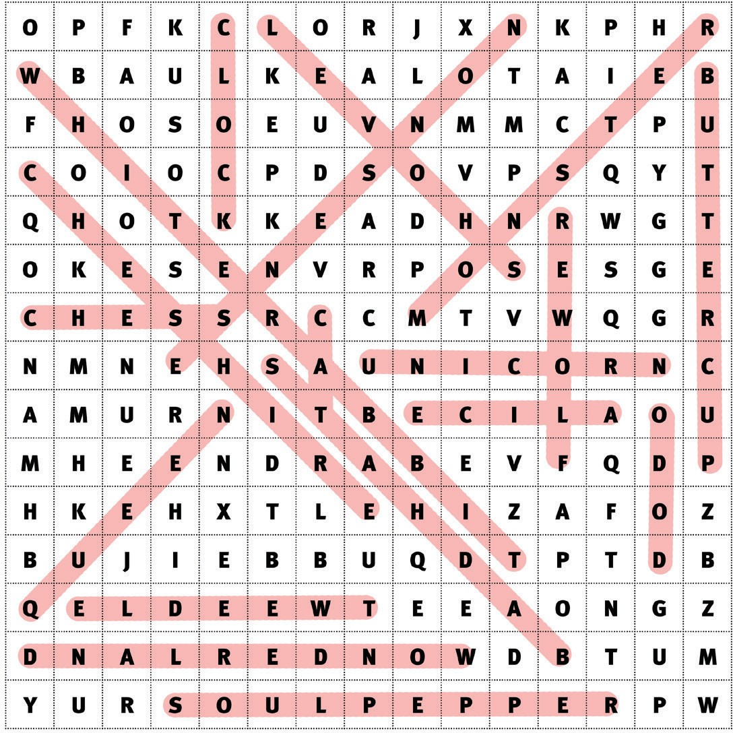
E
M
W |  | H | I | T | E

R | A | B | B | I | T

O’ |  | C | L | O | C | K

N |  | O | N | S | E | N | S | E

D |  | R | I | N | K

E |  | I | G | H | T | H

R |  | I | G | H | T

L |  | I | Z | A | R | D

A |  | N | N

N |  | A | M | E

D |  | O | W | N

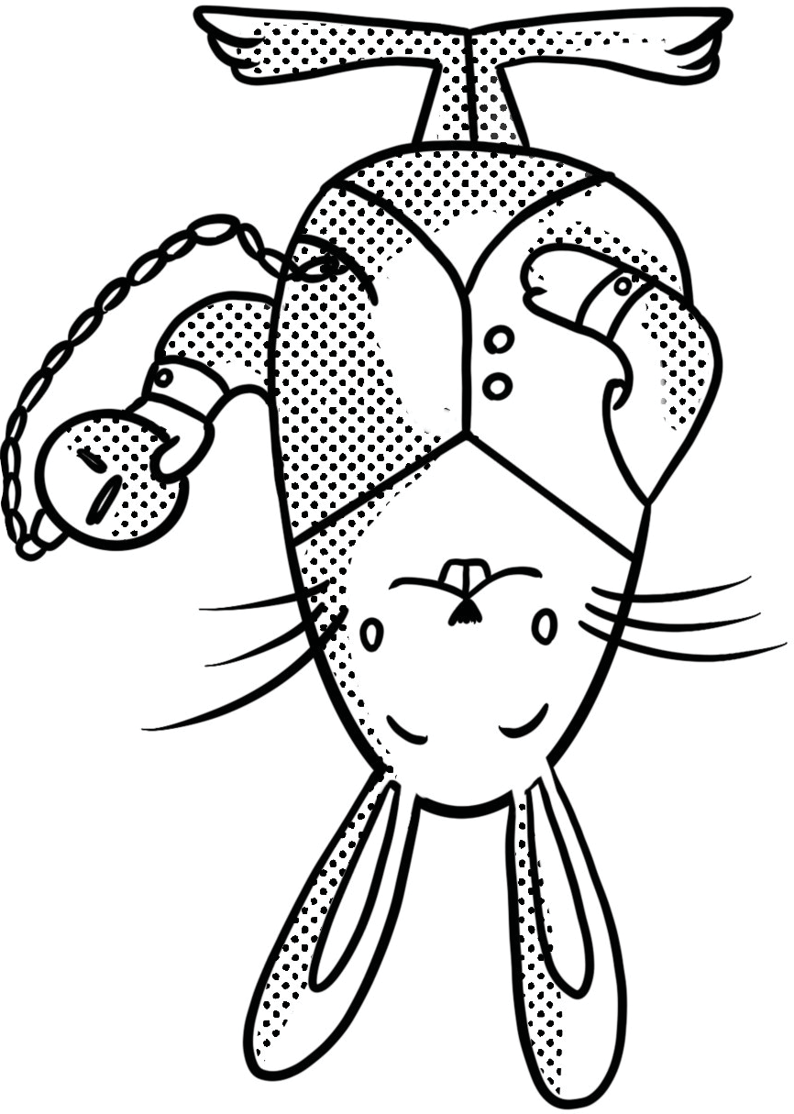
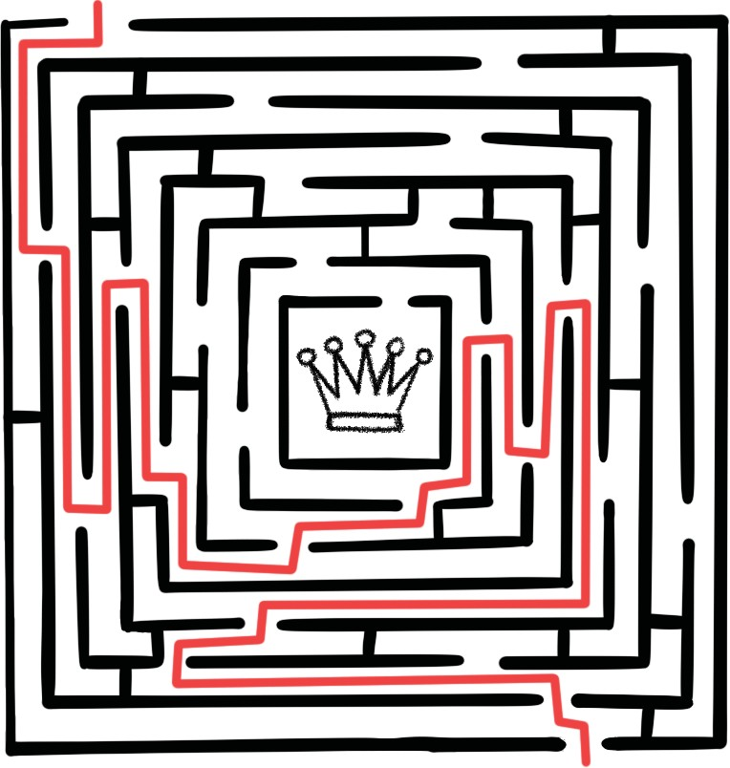
W O N D E R L A N D

